Consensio’s Chalet Grande Corniche in Les Gets awarded
“Best Chalet in France” at 2017 World Ski Awards
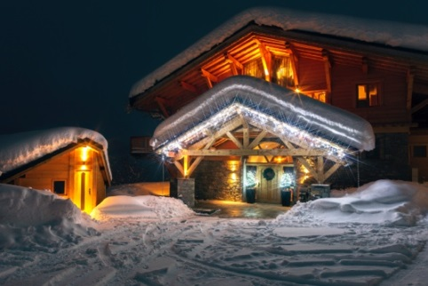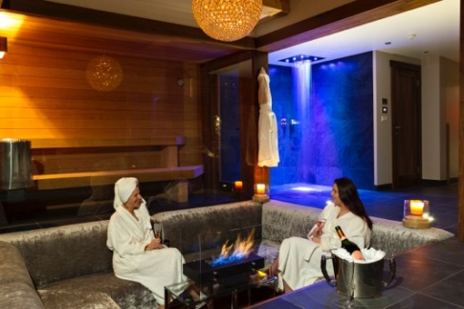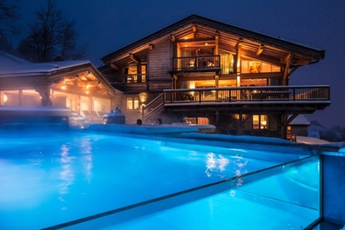

It is with great honour and excitement that Luxury chalet operator Consensio introduces their magnificent chalet, Grande Corniche in Les Gets, as France's Best Ski Chalet for 2017. Awarded at the annual World Ski Awards held in Kitzbühel over the weekend, this comes as their 5th consecutive win in this category. The annual awards ceremony took place on the 18th November 2017, where the chalet received the most votes from the public and industry leaders to clinch this prestigious title. Having been previously crowned with the title in 2015, the Grande Corniche has since elevated luxury to new heights with the addition of an in-chalet cinema and an outdoor heated Ozone infinity swimming pool. Previous Consensio chalets to have been awarded the title include Chalet Marco Polo in Val d’Isere and Chalet Mont Tremblant in Meribel.

One of the largest chalets in the Consensio portfolio, chalet Grande Corniche sleeps 12 adults in six beautifully appointed en-suite bedrooms and 3 children in a fabulous bunk room. The chalet boasts spacious living areas and superb amenities, with far reaching views across the valleys and a 4th floor bar incorporating a slide which whisks you down to the vaulted wine cellar, complete with full size snooker table. The lower ground areas are complemented with a wellness area comprising glass sauna, conversation pit, gym, massage room and shower.

Martin Lightbody, owner of Grande Corniche, was thrilled with the result; “Both Julie and I are absolutely delighted that Grande Corniche has won Best French Ski Chalet of the Year 2017. Since we last won the Award in 2015 we have invested in a two-level family cinema room and a magnificent outdoor, ozone treatment infinity pool. It’s great to have this acknowledged by the industry and we are very proud to have achieved this wonderful award. Credit is also due to our Consensio staff for their professional running of the property during the ski season.”
Consensio exclusively operates a portfolio of 12 hand-picked top end luxury chalets in the French Alps, offering indulgence, convenience and the very highest levels of quality and service. The operator further received a nomination at the awards for “World’s Best Ski Tour operator”, highlighting its position as a global leader within the luxury ski industry.

Consensio Chalets offer Chalet Grande Corniche from £20,700 per week. This price includes use of all the chalet facilities, meals, beverages, and full staff team with chauffeur and chef. For further information or to book visit www.consensiochalets.co.uk or call 0203 393 0833
www.consensiochalets.co.uk | www.worldskiawards.com
***ENDS***
For press information or images please contact Ceri Tinley ceri@consensiochalets.co.uk

