Hair of the Dog with Consensio and WOOF&BREW
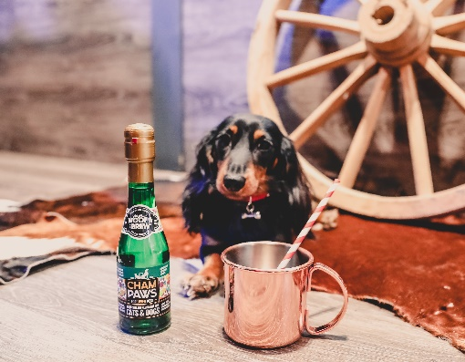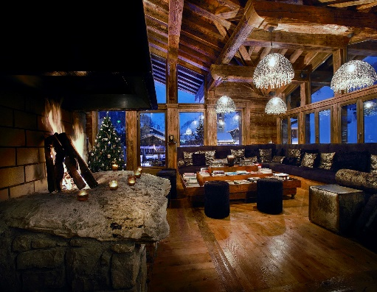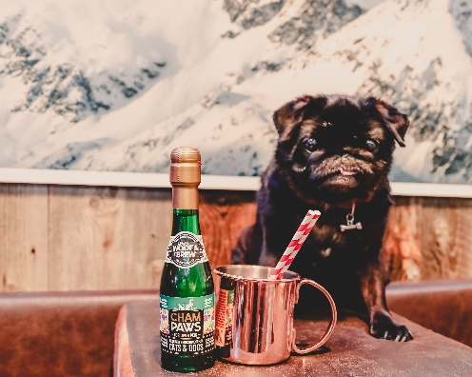
Consensio operates an exquisite portfolio of handpicked, award-winning, dog friendly chalets and luxury self-catering apartments, in the French Alpine resorts of Courchevel, Val d’Isère, Méribel and Les Gets and this coming ski season 2019/2020, the company is excited to announce that they will be offering the first Après Ski for dogs, in partnership with WOOF&BREW.
This year, après ski is open to all at Consensio, the hardcore skiers, chalet dwellers and now even your furry four-legged friends! It’s non-stop for Fido, when lapping up the life of luxury in one of Consensio’s chalets, from early morning snow runs, being chauffeured to meet the humans off the slopes and enjoying exquisite, homecooked meals, and now Consensio has created the pawfect afternoon treat, a chance for your pampered pooch to enjoy a part of the day, which has become synonymous with skiing, Après Ski.
Whilst guests indulge in homemade canapes and cakes, accompanied by a crisp glass of Perrier Jouet Champagne, dogs can join in with a cup of Lapdog Souchong, Earl Greyhound or Bark Jeeling, or alternatively those in need of the hair of the dog, can opt for a bowl of CHAM:PAWS by WOOF&BREW.
WOOF&BREW is the award-winning Pet Drinks Company, and offers some of the most unique, healthy tonics and treats for pampered pets. Not to mention the world's first doggy herbal teabags, packed full of vitamins, minerals and antioxidants, and this year, the company adds a touch of sparkle and style to every pets evening treat, CHAM:PAWS. This light, crisp, non-carbonated drink is made using 100% natural herbs, including lime flower, rose petals and Rooibos, and has been developed with leading veterinary experts, to provide a healthy and nutritious tipple for your pampered pooch.
Guests staying with Consensio are contacted by their own personal concierge team, ahead of departure, to arrange all the finer details of their trip, including whether they would like après ski for their dog.
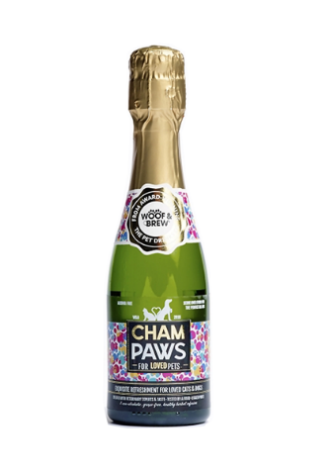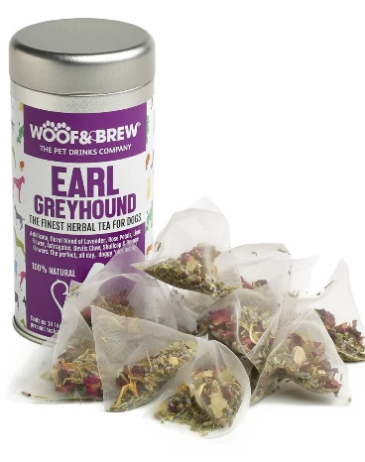
***ENDS***

For more press information and images please contact – 0207 234 9482
Clemmie & Lydia at Kitten & Shark
team@kittenandshark.com

